Links :

<https://www.brainkart.com/subject/Graphics-and-Multimedia_168/>

<https://www.ques10.com/p/32456/explain-mpeg-compression-process-in-detail/>

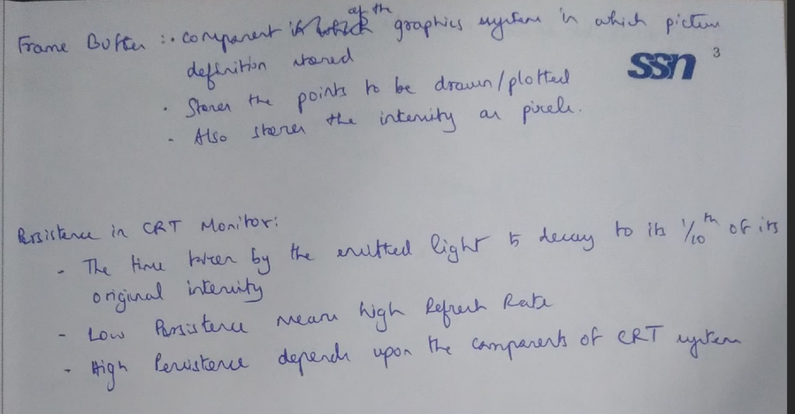

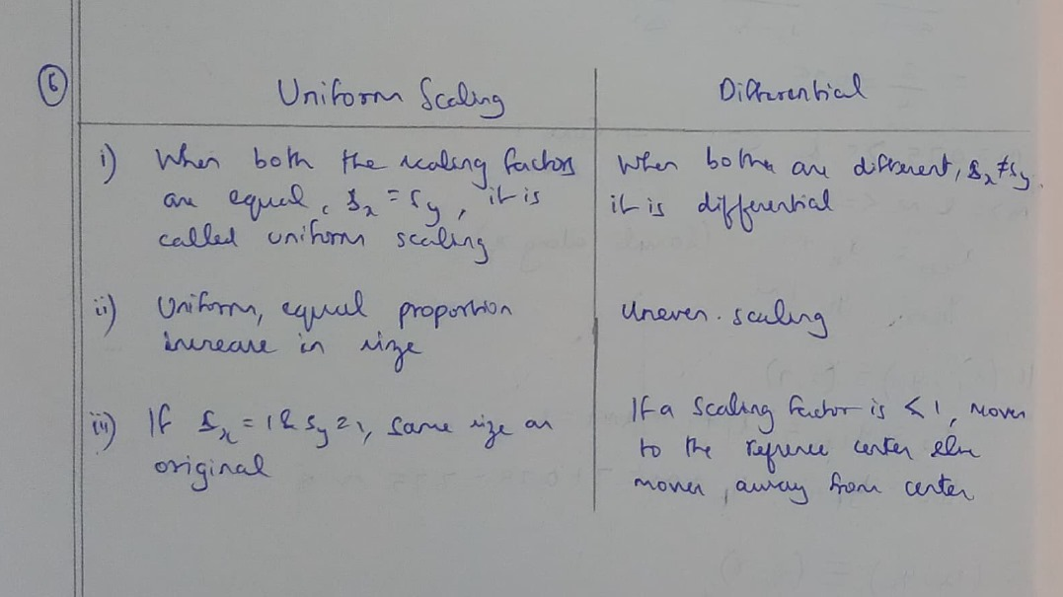

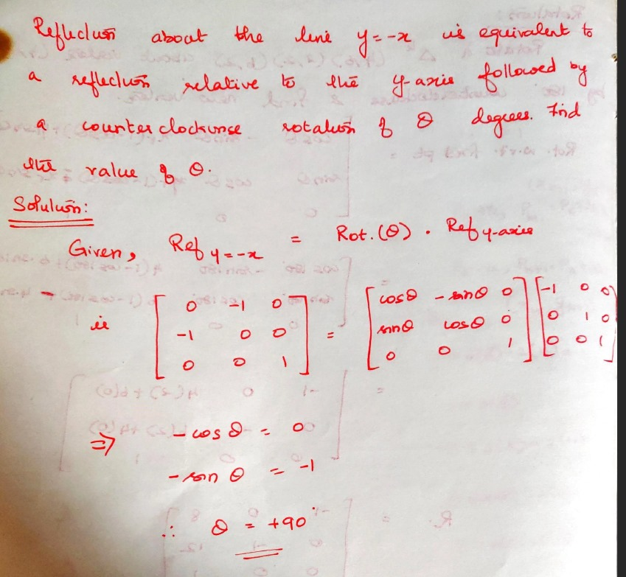

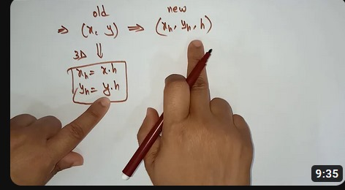

Rigid body transformation -> moves object without deformation

1) Pixel addressing refers to the process of identifying and accessing individual pixels in an image or display. It involves specifying the coordinates of a pixel to manipulate or retrieve its color information.

2) Object geometry pertains to the spatial arrangement and characteristics of objects in a graphical or multimedia environment. It includes details such as size, shape, position, and orientation of objects within a scene.

-----------------

1) Multimedia Elements:

- Text

- Images

- Audio

- Video

- Animation

2) Design Issues in Multimedia Authoring:

1. Display resolution

2. Data formula for capturing data

3. Compression algorithms

4. Network interfaces

5. Storage formats.

3) Multimedia Definition and Applications:

- Multimedia refers to the integration of various media elements like text, graphics, audio, video, and animation.

- Applications: Education (e-learning), Entertainment (gaming, movies), Advertising, Training, Virtual Tours.

4) Basic Objects of Multimedia Systems:

- Text objects

- Image objects

- Audio objects

- Video objects

- Animation objects

5) Modern Multimedia Tools for Rendering 2D and 3D Graphics:

- 2D Graphics: Adobe Illustrator, CorelDRAW

- 3D Graphics: Blender, Autodesk Maya

Hypermedia an extension to hypertext providing multimedia facilities, such as those handling sound and video.

\*Parallel Projection:\*

- Description: In computer graphics, parallel projection is a type of projection where all lines remain parallel, and there is no perspective distortion.

- Applications: Used in technical drawings, engineering designs, architectural blueprints, and isometric views in computer-aided design (CAD) software.

\*Depth Cueing:\*

- Description: Depth cueing is a technique used to add depth perception to a scene by varying visual elements based on the distance from the viewer.

- Applications: Applied in computer graphics, 3D rendering, and virtual reality to enhance the perception of depth, aiding users in understanding the spatial relationships within a scene.

The decision of where to perform compression and decompression in a document imaging system involves trade-offs and considerations related to processing efficiency, storage requirements, and the overall system performance. The three primary locations for compression in a document imaging system are the scanner node, the host system, and the storage node. Let's examine the implications of each:

1. \*Compression in the Scanner Node:\*

- Implications:

- \*Pros:\* Reduces the amount of data transmitted over the network, as compressed data is sent to the host system.

- \*Cons:\* Requires additional processing power in the scanner, potentially increasing the cost and complexity of the scanner hardware.

2. \*Compression in the Host System:\*

- Implications:

- \*Pros:\* Centralizes compression and decompression tasks, allowing for easier management and updates.

- \*Cons:\* Increases the load on the host system's CPU, which may affect overall system performance, especially if handling multiple scanners or high-volume scanning operations.

3. \*Compression in the Storage Node:\*

- Implications:

- \*Pros:\* Reduces the demand on the scanner and host system, allowing them to focus on their primary tasks. The storage node handles compressed data storage and retrieval.

- \*Cons:\* May lead to higher network traffic, as uncompressed data is transmitted between the scanner and host system. The storage node requires additional processing power for decompression during retrieval.

\*Overall Implications:\*

- \*Processing Overhead:\* The choice of where to perform compression and decompression introduces processing overhead at different stages of the document imaging workflow. Placing these tasks in the scanner may affect the speed and efficiency of the scanning process, while doing it in the host system impacts its processing capabilities.

- \*Network Traffic:\* If compression occurs at the scanner node, the network traffic between the scanner and host system is reduced. However, if compression is delayed until the storage node, network traffic may increase during data transfer.

- \*Storage Requirements:\* Compressing images before storage reduces the amount of storage space required. However, the type of compression algorithm used can impact the balance between compression ratios and image quality.

- \*Flexibility and Scalability:\* Centralized compression in the host system provides more flexibility in updating compression algorithms or adapting to changes. On the other hand, distributing compression tasks across multiple nodes may offer scalability benefits in a distributed system.

- \*Cost Considerations:\* The choice of where to perform compression can have cost implications. More processing power in the scanner or storage nodes may increase hardware costs, while relying on the host system may necessitate a more powerful and costly central processing unit.

In conclusion, the optimal location for compression and decompression in a document imaging system depends on the specific requirements, hardware capabilities, and priorities of the system architecture. Balancing the trade-offs and considering factors such as network efficiency, processing capabilities, and storage requirements are crucial in designing an effective and efficient document imaging system.

A video conferencing application can be related to hypermedia messaging through the integration of various media types and interactive elements. Hypermedia refers to the combination of multimedia elements, such as text, images, audio, video, and links, to create a rich and interactive user experience. In the context of a video conferencing application, hypermedia messaging adds an extra layer of functionality and enhances communication by providing a seamless transition between real-time video communication and integrated stored messaging.

\*Justification of Video Conferencing as Hypermedia Messaging:\*

1. \*Multimedia Integration:\*

- Video conferencing inherently involves the integration of multiple media types, including video and audio. Hypermedia messaging extends this integration by allowing users to incorporate additional elements like images, documents, and links during or after a video call.

2. \*Interactive Elements:\*

- Hypermedia messaging introduces interactive elements such as clickable links, annotations, and multimedia attachments. In a video conferencing scenario, this could mean sharing documents, images, or links in real-time, enhancing collaboration and information sharing.

3. \*Seamless Transition:\*

- Hypermedia messaging enables a seamless transition between real-time communication and stored messaging. Users can move from a live video conference to an integrated messaging system without disruptions, preserving the context of the conversation.

4. \*Enhanced Collaboration:\*

- By incorporating hypermedia elements, users can collaborate more effectively during a video conference. For example, they can share documents, annotate visuals, or provide additional information through hyperlinks, fostering a more dynamic and engaging communication environment.

\*Implications of Building a System with Video Conferencing and Integrated Stored Messaging:\*

1. \*Context Preservation:\*

- Users can start a conversation through video conferencing and seamlessly switch to integrated stored messaging to continue discussions or share additional information. This preserves the context of the conversation and allows for asynchronous collaboration.

2. \*Information Retention:\*

- Integrated stored messaging facilitates information retention by providing a repository for messages, files, and multimedia exchanged during video conferences. Users can refer back to stored content for review or reference, improving information accessibility.

3. \*Flexibility and Convenience:\*

- Building a system that supports both video conferencing and integrated stored messaging offers users flexibility in communication. They can choose the most suitable mode based on the nature of the conversation, ensuring convenience and adaptability to different communication needs.

4. \*Collaboration Efficiency:\*

- The combination of real-time video conferencing and integrated stored messaging enhances collaboration efficiency. Users can address immediate concerns through video, and then switch to messaging for detailed discussions, file sharing, or collaborative editing, optimizing the use of time and resources.

5. \*User Engagement:\*

- A system that seamlessly integrates video conferencing and hypermedia messaging enhances user engagement by providing a versatile communication platform. Users are more likely to be engaged when they have the flexibility to choose the most effective mode of communication for their specific needs.

In conclusion, the integration of video conferencing and hypermedia messaging creates a comprehensive communication platform that offers users flexibility, enhances collaboration, and provides a dynamic and engaging user experience. Such a system allows for a seamless transition between real-time communication and stored messaging, addressing the diverse communication requirements of users in different scenarios.

---------------------------

Superquadrics are 3D geometric shapes defined by a parametric equation that combines both ellipsoids and hyperboloids. They offer a versatile representation of complex 3D forms